**Background:**

You will be working with a partner to write a pair of programs that will secretly encode a text file and then decode the file back to plain text.

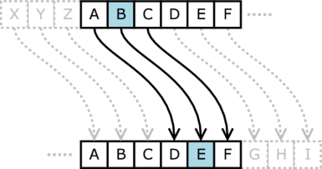In a previous lesson you have already implemented a simple   
shift code (Caesar Cipher) that added 3 to the ASCII code of a letter.   
The Caesar cipher is one of the earliest known and simplest ciphers.   
It is a type of substitution cipher in which each letter in the plaintext   
is 'shifted' a certain number of places down the alphabet. If the shift   
is greater than ‘z’ then the shift wraps around to “a’.

The sample program below does the following to implement the Caesar Cipher:

1. Reads a line of text from the console input
2. Loops through each character in the line of text
3. Checks that the character is a printable letter
4. Shifts the letter by 3 positions (wrapping back to “a” if necessary)
5. Appends the shifted letter a new line of coded text
6. At the end of the program, prints the line of coded text to the console display.

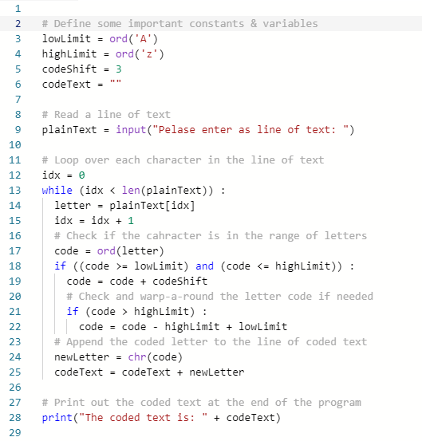

**Assignment:**

1. Work with a partner to create a Substitution Cipher Key (See the assignment slide notes for more information)
2. Partner #1 will write a program to do the following:
   1. Open a text file called “MessageText.txt” for reading
   2. Open a text file called “CodedText.txt” for writing
   3. Loop over each line of text in the message file
   4. Code each line of text using the Substitution Cipher Key
   5. Write each line of coded text to the code file
   6. Close both the message file and code file
3. Partner #2 will write a program to do the following:
   1. Open the text file called “CodedText.txt” for reading
   2. Open a text file called “DecodedText.txt” for writing
   3. Loop over each line of text in the coded text file
   4. De-Code each line of text using the Substitution Cipher Key
   5. Write each line of de-coded text to the de-code file
   6. Close both the code file and de-code file
4. Your programs should work for messages that contain multiple lines of text.
5. Be prepared to demonstrate and explain your coding / de-coding program and code files.

**Programming Hints:**

Use the sample Caesar Cipher program as a starting point

Get you program to work with single lines of text from console input / output before adding the use of files. (It is easier to debug console input / output than file input / output.)

Implement your key using the list data type. An example code is as follows:

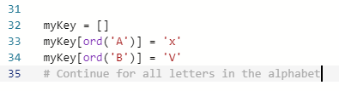

#Martin, Ritik, and Ibrahims Code

L2I = dict(zip("ABCDEFGHIJKLMNOPQRSTUVWXYZ",range(26)))

I2L = dict(zip(range(26),"ABCDEFGHIJKLMNOPQRSTUVWXYZ"))

fileHandle = open("messageSent/messageText.txt" , "r+")

numLines = 0

for line in fileHandle :

print (line)

fileHandle.close()

key = 8

plainText = (line)

# encipher

cipherText = ""

for c in plainText.upper():

if c.isalpha(): cipherText += I2L[ (L2I[c] + key)%26 ]

else: cipherText += c

# decipher

plainText2 = ""

for c in cipherText.upper():

if c.isalpha(): plainText2 += I2L[ (L2I[c] - key)%26 ]

else: plainText2 += c

print (cipherText)

fileHandle = open("codedMessage/codedText.txt", "w+")

fileHandle.write (cipherText)

fileHandle.close()

fileHandle = open("codedTextoverWrite", "w+")

fileHandle.write (cipherText)

fileHandle.close ()

fileHandle = open ("decodedText", "w+")

fileHandle.write (plainText2)

fileHandle.close ()

In a folder, with in a file titled codedText

BPQA QA GWCZ TIAB KPIVKM. INBMZ BPQA, BPMZM QA VW BCZVQVO JIKS. GWC BISM BPM JTCM XQTT - BPM ABWZG MVLA, GWC EISM CX QV GWCZ JML IVL JMTQMDM EPIBMDMZ GWC EIVB BW JMTQMDM. GWC BISM BPM ZML XQTT - GWC ABIG QV EWVLMZTIVL IVL Q APWE GWC PWE LMMX BPM ZIJJQB-PWTM OWMA. (UWZXPMCA - BPM UIBZQF)

In a folder, with a text file titled messageText

This is your last chance. After this, there is no turning back. You take the blue pill - the story ends, you wake up in your bed and believe whatever you want to believe. You take the red pill - you stay in Wonderland and I show you how deep the rabbit-hole goes. (Morpheus - The Matrix)

THIS IS YOUR LAST CHANCE. AFTER THIS, THERE IS NO TURNING BACK. YOU TAKE THE BLUE PILL - THE STORY ENDS, YOU WAKE UP IN YOUR BED AND BELIEVE WHATEVER YOU WANT TO BELIEVE. YOU TAKE THE RED PILL - YOU STAY IN WONDERLAND AND I SHOW YOU HOW DEEP THE RABBIT-HOLE GOES. (MORPHEUS - THE MATRIX)